**Module 3 – Mernstack – CSS and CSS3**

**Question 1: What is a CSS selector? Provide examples of element, class, and ID selectors.**

A **CSS selector** is a pattern used to select and style specific HTML elements in a web page. It tells the browser which elements to apply the specified CSS rules to.

**Examples of CSS Selectors**

* **Element Selector**

Targets all instances of a specific HTML element.

**p{**

**color: blue;**

**}**

This example will style all <p> (paragraph) elements with blue text.

* **Class Selector**

Targets elements with a specific class attribute. Classes are reusable across multiple elements.

**.highlight {**

**background-color: yellow;**

**}**

This example will style any element with the *class="highlight"* attribute by giving it a yellow background.

* **ID Selector**

Targets an element with a specific id attribute. IDs are unique and should be used only once per page.

#header {

font-size: 24px;

}

This example will style the element with id="header" by setting its font size to 24px.

Example usage in HTML

<h1 id="header">This is the page header.</h1>

These selectors are the foundation of CSS and can be combined or used with more advanced techniques for precise styling.

**Question : Explain the concept of CSS specificity. How do conflicts between multiple styles get resolved?**

**What is CSS Specificity?**

CSS specificity is a set of rules that determines which CSS styles are applied when there are conflicting styles for the same element. It is essentially a ranking system that prioritizes some rules over others.

Each type of CSS selector has a different **specificity weight**. The higher the specificity, the more precedence a rule has.

**Specificity Weighting**

Specificity is calculated based on the following criteria (in order of importance):

1. **Inline styles** (added directly to an element using the style attribute) have the highest specificity.
   * Example: <p style="color: red;">
2. **ID selectors** (#id) are more specific than classes or element selectors.
   * Example: #header
3. **Class selectors**, **attribute selectors**, and **pseudo-classes** (e.g., .class, [type="text"], :hover) have moderate specificity.
   * Example: .highlight
4. **Element selectors** and **pseudo-elements** (e.g., p, h1, ::before) have the lowest specificity.
   * Example: p

**Specificity Hierarchy**

CSS calculates specificity using a point system:

* Inline styles: **1,0,0,0**
* ID selectors: **0,1,0,0**
* Class, attribute, and pseudo-class selectors: **0,0,1,0**
* Element and pseudo-element selectors: **0,0,0,1**

### ****Resolving Conflicts****

When multiple rules target the same element:

**Higher specificity wins**: A more specific selector overrides a less specific one.

#title {

color: blue;

}

.highlight {

color: red;

}

h1 {

color: green;

}

For <h1 id="title" class="highlight">, the text color will be **blue** because #title has the highest specificity.

* **If specificity is the same**, the rule that appears later in the stylesheet (or is closer to the element in the cascade) takes precedence.

.highlight

{

color: red;

}

.highlight {

color: green;

}

The text will be **green**, as the second .highlight rule is applied last.

* **Inline styles override all external stylesheets**:

**<p id="text" style="color: yellow;">This text is yellow.</p>**

Even if an external stylesheet sets #text { color: blue; }, the text will remain yellow due to the inline style.

* **Use of !important**:

**A rule with !important will override all other rules, regardless of specificity, except another !important rule with higher specificity.**

p {

color: green !important;

}

.highlight {

color: blue;

}

The paragraph will be **green**, as !important overrides everything else.

**Question What is the difference between internal, external, and inline CSS?**

CSS can be applied to HTML using three main methods: **internal CSS**, **external CSS**, and **inline CSS**. Each method has its own use case and characteristics.

### ****1. Internal CSS****

Internal CSS is defined within a <style> tag in the <head> section of an HTML document. It is used when styles are only needed for a single page.

Example

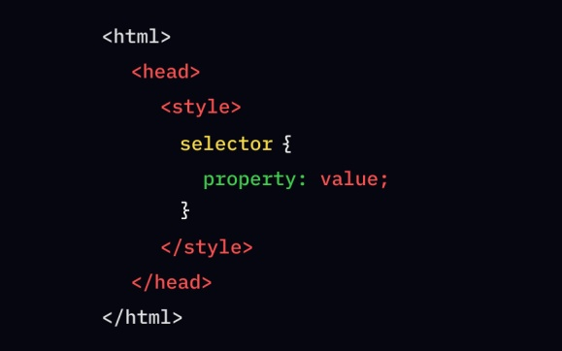

#### ****Characteristics****:

* **Scope**: Styles are applied only to the specific HTML file in which they are defined.
* **Advantages**:
  + Keeps styles separate from the content structure.
  + Useful for quick, single-page styling.
* **Disadvantages**:
  + Not reusable across multiple pages.
  + Can clutter the HTML file if many styles are included.

**2. External CSS**

External CSS is written in a separate .css file and linked to the HTML document using the <link> tag. It is the most commonly used method for large projects.

Example in Html

<html>

<head>

<title>Home</title>

<link rel="stylesheet" href="style.css">

</head>

<body>

<h1>This is a heading</h1>

<p>This is a paragraph.</p>

<p>This is another paragraph.</p>

</body>

</html>

**Now in EXTERNAL CSS**

h1{

color: blue;

}

p{

color: green;

}

#### ****Characteristics****:

* **Scope**: Styles can be shared across multiple HTML files.
* **Advantages**:
  + Promotes reusability and maintainability.
  + Keeps the HTML file cleaner and more readable.
  + Easy to update styles across multiple pages by modifying a single file.
* **Disadvantages**:
  + Requires an additional HTTP request to fetch the CSS file (though this can be mitigated by caching).
  + Not ideal for small projects with limited styling needs.

### ****3. Inline CSS****

Inline CSS is applied directly to an HTML element using the style attribute. It is the most specific method of applying styles.

**Example**

**<!DOCTYPE html>**

**<html>**

**<body>**

**<h1 style="color: navy; background-color: lightblue;">Welcome to My Page</h1>**

**</body>**

**</html>**

#### ****Characteristics****:

* **Scope**: Styles apply only to the specific element where they are written.
* **Advantages**:
  + Quick and easy for small, specific changes.
  + Does not require a separate CSS file or <style> block.
* **Disadvantages**:
  + Does not separate content and presentation, making the code harder to maintain.
  + Increases file size and redundancy if applied to multiple elements.
  + Overrides external and internal CSS unless !important is used.

**CSS BOX MODEL**

**Question : Explain the CSS box model and its components (content, padding, border, margin). How does each affect the size of an element?**

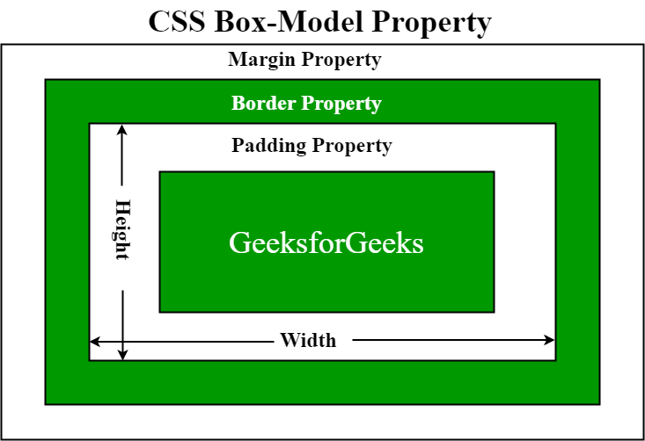

The CSS box model is a way to think of HTML elements as rectangular boxes with four main parts: content, padding, border, and margin. Each part affects the size of the element in different ways\

**Content**

* The area where the content of the element is displayed, such as text, images, or videos
* The size of the content box is determined by the amount of content and its size

**Padding**

* The space between the content and the border
* Padding can be applied to all sides of the box or to specific sides
* Increasing the padding makes the content look cleaner and easier to read

**Border**

* The area that surrounds the padding and content
* The border can be applied to all sides of the box or to specific sides
* The thickness of the border affects the height and width of the element

**Margin**

* The space between the border of the element and other elements
* The margin is transparent and shows the background color of the element
* Increasing the margin makes the space between elements larg

**How do these parts affect the size of an element**

* The default width and height of an element only applies to the content box
* The border and padding are added to the width and height to determine the size of the box on the screen
* The margin affects the total space the box takes up on the page, but it's not included in the box's actual size

**Question : What is the difference between border-box and content-box box-sizing in CSS? Which is the default?**

border-box and content-box are the two different values of box-sizing. content-box: This is the default value of box-sizing. The dimension of element only includes 'height' and 'width' and does not include 'border' and 'padding' given to element. Padding and Border take space outside the element

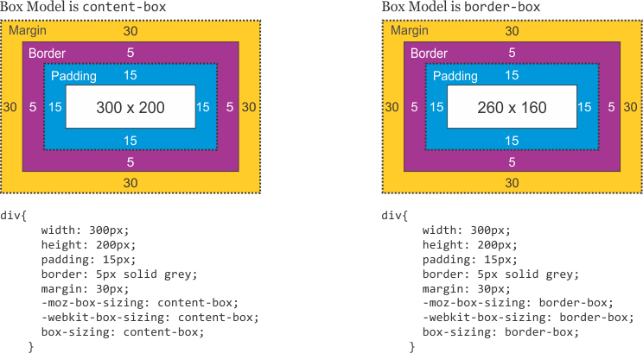

**CSS Flexbox**

**Question 1: What is CSS Flexbox, and how is it useful for layout design? Explain the terms flex-container and flex-item.**

**What is CSS Flexbox?**

CSS Flexbox, short for **Flexible Box Layout**, is a layout model in CSS designed to provide a more efficient way to align, distribute, and organize items within a container. It excels in creating responsive designs, allowing elements to adjust dynamically based on the size of their container and the available space. Flexbox is particularly useful for one-dimensional layouts, either along a horizontal or vertical axis.

**Key Features of Flexbox:**

1. **Flexible Sizing**: Elements can shrink or grow based on container space.
2. **Alignment Options**: Align elements horizontally and vertically without using complex hacks.
3. **Reordering**: Items can be reordered visually without changing the underlying HTML structure.
4. **Responsiveness**: Handles dynamic resizing and rearrangement of content on different screen sizes.

### Key Terms in Flexbox:

1. **Flex Container**:
   * The parent element that holds the flex items.
   * Defined by setting the display property to flex or inline-flex.
   * The flex container dictates how its child elements (flex items) behave and are arranged.
2. **Flex Item**:

* The child elements of a flex container.
* These items follow the layout rules defined by the container.
* They can be manipulated individually using properties like flex-grow, flex-shrink, and flex-basis.

### Key Properties of Flexbox:

#### On the ****Flex Container****:

* **flex-direction**: Determines the main axis (row, column, etc.).
* **justify-content**: Aligns items along the main axis.
* **align-items**: Aligns items along the cross axis.
* **align-content**: Controls the space between rows (if there are multiple lines).
* **flex-wrap**: Allows items to wrap onto new lines if needed.

#### On the ****Flex Items****:

* **order**: Changes the order of items.
* **flex-grow**: Defines how much space an item can take up relative to others.
* **flex-shrink**: Specifies how much an item should shrink when space is limited.
* **flex-basis**: Sets the default size of an item before resizing.
* **align-self**: Aligns a single item independently along the cross axis.

### Why is Flexbox Useful for Layout Design?

1. **Simplifies Alignment**: Aligning items vertically or horizontally becomes straightforward.
2. **Space Distribution**: It dynamically distributes available space among items.
3. **Responsive Design**: Handles resizing and wrapping, making layouts adapt to different screen sizes.
4. **Eliminates Float/Clear Fixes**: Replaces older CSS techniques like floats for layouts.
5. **Versatile**: Works well for both small components (like navigation bars) and larger structures (like entire page layouts).

By mastering Flexbox, you can create modern, clean, and efficient layouts with minimal code.

**Question 2: Describe the properties justify-content, align-items, and flex- direction used in Flexbox.**

Here’s a breakdown of the **justify-content**, **align-items**, and **flex-direction** properties in Flexbox:

### 1. justify-content

The justify-content property is used to align flex items **along the main axis** (the primary axis defined by the flex-direction property). It controls the horizontal alignment for flex-direction: row and vertical alignment for flex-direction: column.

#### Common Values:

* **flex-start**: Items are aligned at the beginning of the main axis (default value).
* **flex-end**: Items are aligned at the end of the main axis.
* **center**: Items are centered along the main axis.
* **space-between**: Items are spaced out evenly, with the first item at the start and the last item at the end.
* **space-around**: Items are evenly spaced, but there’s half-size spacing at the start and end.
* **space-evenly**: Items are evenly distributed with equal spacing between them and around them.

### 2. align-items

The align-items property aligns flex items **along the cross axis** (perpendicular to the main axis). It determines how the items are positioned vertically (for flex-direction: row) or horizontally (for flex-direction: column).

#### Common Values:

* **stretch**: Items stretch to fill the container along the cross axis (default value).
* **flex-start**: Items are aligned at the start of the cross axis.
* **flex-end**: Items are aligned at the end of the cross axis.
* **center**: Items are centered along the cross axis.
* **baseline**: Items are aligned along their text baseline.

### 3. flex-direction

The flex-direction property defines the direction of the main axis, determining the flow of flex items in the container.

#### Common Values:

* **row**: Items are placed from left to right (default value).
* **row-reverse**: Items are placed from right to left.
* **column**: Items are placed from top to bottom.
* **column-reverse**: Items are placed from bottom to top.

**CSS Grid**

**Question : Explain CSS Grid and how it differs from Flexbox. When would you use Grid over Flexbox?**

**What is CSS Grid?**

CSS Grid is a **two-dimensional layout system** in CSS that allows you to design web pages by creating layouts in rows and columns simultaneously. It provides a powerful way to divide a webpage into regions or align items within a container.

CSS Grid uses a **grid container** (parent) that defines rows and columns, and **grid items** (children) that are placed within the defined grid structure.

**Key Features of CSS Grid:**

1. **Two-dimensional Layout**: Works on both rows and columns at the same time, making it ideal for complex layouts.
2. **Explicit Control**: You can define the size, position, and spacing of rows and columns with precision.
3. **Template Areas**: Allows naming grid areas, making layouts easier to manage and visualize.
4. **Responsive Design**: Easily adapts to different screen sizes using fractional units, auto-sizing, and media queries.

**What is CSS Grid?**

CSS Grid is a **two-dimensional layout system** in CSS that allows you to design web pages by creating layouts in rows and columns simultaneously. It provides a powerful way to divide a webpage into regions or align items within a container.

CSS Grid uses a **grid container** (parent) that defines rows and columns, and **grid items** (children) that are placed within the defined grid structure.

**Key Features of CSS Grid:**

1. **Two-dimensional Layout**: Works on both rows and columns at the same time, making it ideal for complex layouts.
2. **Explicit Control**: You can define the size, position, and spacing of rows and columns with precision.
3. **Template Areas**: Allows naming grid areas, making layouts easier to manage and visualize.
4. **Responsive Design**: Easily adapts to different screen sizes using fractional units, auto-sizing, and media querie

**How CSS Grid Differs from Flexbox**

| **Feature** | **CSS Grid** | **Flexbox** |
| --- | --- | --- |
| **Layout Type** | Two-dimensional (rows and columns). | One-dimensional (row *or* column). |
| **Usage** | Best for entire page layouts or large sections. | Best for aligning smaller components like navigation bars. |
| **Alignment** | Rows and columns can be aligned simultaneously. | Aligns items along a single axis at a time. |
| **Explicit Positioning** | Provides direct placement of items using grid lines or named areas. | No direct placement; items are arranged in sequence. |
| **Responsiveness** | Built-in tools like grid-template-areas and fractional units (fr). | Relies on properties like flex-grow and wrapping for responsiveness. |

### When to Use CSS Grid Over Flexbox

#### Use ****CSS Grid**** when:

1. **You need a two-dimensional layout**:
   * For example, creating a webpage with a header, sidebar, main content, and footer.
2. **Precise placement is required**:
   * For example, positioning items in specific rows and columns.
3. **You’re building larger layouts**:
   * Complex layouts like dashboards, gallery grids, or multi-sectioned web pages are easier with Grid.

#### Use ****Flexbox**** when:

1. **You need a one-dimensional layout**:
   * For example, creating a navigation bar, buttons, or aligning items in a single row or column.
2. **Content size is dynamic**:
   * For example, layouts where items need to shrink or grow based on the container's size.
3. **You need to align items quickly**:
   * For example, centering items within a container using justify-content or align-items.

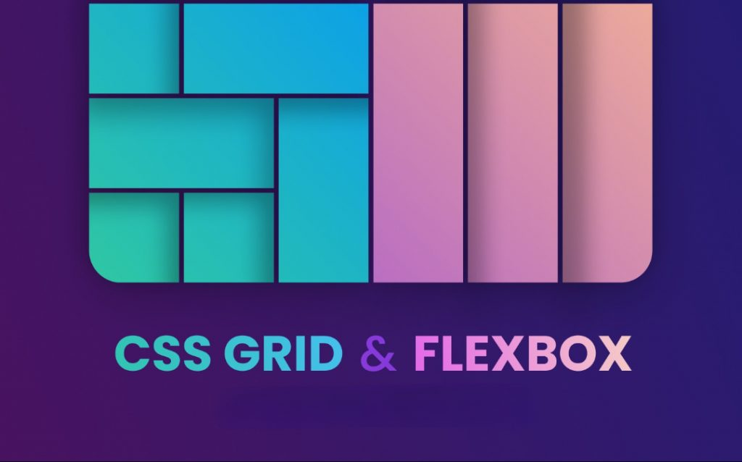

**Question : Describe the grid-template-columns, grid-template-rows, and grid- gap properties. Provide examples of how to use them.**

### Description of Properties in CSS Grid

#### 1. grid-template-columns

The grid-template-columns property defines the number, size, and layout of **columns** in a grid container. It specifies the column widths and creates the structure for grid items.

* Values can be:
  + **Fixed Units**: px, em, rem, etc. (e.g., 100px 200px)
  + **Flexible Units**: % or fr (fractional units, like 1fr, to distribute space proportionally).
  + **Auto**: Automatically sizes columns based on content.
  + **Repeat() Function**: Simplifies repetitive column definitions.

Example:

**.container {**

**display: grid;**

**grid-template-columns: 100px 200px 1fr;**

**}**

* Creates 3 columns:
  + First column: 100px wide.
  + Second column: 200px wide.
  + Third column: Takes up the remaining available space.

### Description of Properties in CSS Grid

#### 1. grid-template-columns

The grid-template-columns property defines the number, size, and layout of **columns** in a grid container. It specifies the column widths and creates the structure for grid items.

* Values can be:
  + **Fixed Units**: px, em, rem, etc. (e.g., 100px 200px)
  + **Flexible Units**: % or fr (fractional units, like 1fr, to distribute space proportionally).
  + **Auto**: Automatically sizes columns based on content.
  + **Repeat() Function**: Simplifies repetitive column definitions.

**Example:**

css

CopyEdit

.container {

display: grid;

grid-template-columns: 100px 200px 1fr;

}

* Creates 3 columns:
  + First column: 100px wide.
  + Second column: 200px wide.
  + Third column: Takes up the remaining available space.

#### 2. grid-template-rows

The grid-template-rows property defines the number, size, and layout of **rows** in a grid container. It works similarly to grid-template-columns but for rows.

* Values are the same as for grid-template-columns.

**Example:**

**.container {**

**display: grid;**

**grid-template-rows: 100px auto 2fr;**

**}**

* Creates 3 rows:
  + First row: 100px high.
  + Second row: Automatically sized based on content.
  + Third row: Takes up twice as much space as a single fr unit.

#### 3. grid-gap ****(or**** gap****)****

The grid-gap property defines the spacing **between rows and columns** in the grid. It has been replaced by the shorthand gap in modern CSS but is still supported in older browsers.

* **Syntax**:
  + gap: row-gap column-gap;
  + If a single value is provided, it applies to both row and column gaps.

**Example:**

**.container {**

**display: grid;**

**grid-template-columns: 1fr 1fr;**

**grid-template-rows: auto;**

**gap: 20px 30px; /* 20px row gap, 30px column gap */**

**}**

**Adds 20px of space between rows and 30px between columns.**